**Southern Beaufort Sea Polar Bear, *Ursus arctos maritimus,* Population Viability Analysis -Modeling the Effects of Sea Ice Decline and Harvest on a Declining Population-**

Justice Best, Colton Irons, Brandon Reeder

April 23, 2019

Written Project Rough Draft

NRES 470 Lab Section

[**https://insightmaker.com/insight/163831/PVA-polar-bears**](https://insightmaker.com/insight/163831/PVA-polar-bears)

**Introduction**

Polar bears, *Ursus arctos maritimus* have a circumpolar distribution composed of nineteen sub populations (Bromaghin et al., 2015, Allen et al., 2010)).  Historically these subpopulations experienced healthy genetic exchange through connectivity with adjacent populations, which is considered crucial for the persistence of the species. Individual bears, especially males, have extremely large, loosely defined territories that may overlap with those of other individuals (Allen et al., 2010).  Polar bear’s diet consists almost exclusively of seals, and they rely on sea ice to hunt their prey. Over the last several decades global climate trends have resulted in longer warm periods in the northern hemisphere causing unpresented sea ice loss and extreme environmental stress on the Southern Beaufort Sea subpopulation (Bromaghin et al., 2015). The range of the SB subpopulation is located from northern Alaska and western Canada north to the arctic basin. It is bordered on the east by a relatively understudied population ranging from northwestern Alaska to Siberia and on the northwest by the Northern Beaufort Sea subpopulation, which is considered stable. Polar bears in this region have a strong preference for ice over the continental shelf in the southern part of the sea where depths are less than 300m (Allen et al., 2010). With premature ice melt in this part of the sea, bears get left stranded and are forced to swim daunting distances in search of habitat (Bromaghin et al., 2015).  Some SB bears are acclimating by utilizing marginal shoreline habitat for building dens and scavenging meals, but there is not enough shoreline habitat to accommodate all the bears in the region. As a direct result of sea ice loss, this subpopulation experiences enormous declines in regional carrying capacity (K) during the summer months. On years with extended ice-free days bears have been found deceased or in very poor condition after weeks or even months of fasting (Bromaghin et al., 2015). Previous analyses of SB polar bear population have primarily focused on the effects of sea ice loss, but do not examine the effects of harvest by indigenous people. This population viability analysis examines the effects harvest and sea ice loss may have on the future of this population.

**Methods**

This Population Viability Analyses used a model designed with the program Insight Maker. The first simulations ran used an initial population of 900 bears in accordance with 2010 abundance estimates (Bromaghin et al., 2015). The model simplifies SB polar bear population demographics by parameterizing general population trends and omitting age and sex structure to more effectively demonstrate the effects of different management approaches regarding harvest in a population with a highly stochastic carrying capacity. The model also ignores emigration and immigration.  Growth in the model is by recruitment only and decline is only affected mortality and harvest. Mortality and recruitment rates are directly affected by carrying capacity(K), which is dependent on the number of ice-free days.

The birth rate in the model varies depending on K. Fecundity rates for polar bears are difficult to obtain from existing data, but it is estimated that on a normal year the global population can increase by 6%.  Recruitment in the model is determined by multiplying the total population by the birth rate per capita. Birth rate uses a max fecundity of 6 percent with a 1.5 percent standard deviation. When the population is below 80 percent of carrying capacity it experiences max fecundity, otherwise it diminishes quickly as a function of K until it reaches .05% (max fecundity)-(max fecundity)*(Polar bear population/K).  On low ice years, levels of successful recruitment are negligibly low. Death rate is also conditional. If the polar bear population is less than K,the death rate will follow global trends and stay between 1%-3% (Bromaghin, et.al., 2015). If the polar bear population is greater than the carrying capacity, the death rate will increase to a conservatively low estimated range from 2.5% to 7.5% of the total population plus that year’s recruitment to demonstrate how death rates increase during low ice years.

In this model carrying capacity is a function of the number of ice-free days. A maximum carrying capacity of 1800 was estimated based on historic abundance estimates of about 1600 in the region and the assumption that natives have been participating in a sustainable harvest of bears since before records existed. Ice free days are defined as days when less than 40 percent of the continental shelf is covered in ice as determined by satellite imaging. Many of the simulations ran during this PVA used the mean ice-free days in the SBS from 2000 to 2005 of 114. It has been determined that 127 ice free days is a threshold that when exceeded has a dramatic negative impact on polar bear fitness. 127 is the value between the means from good years, 2001-2003, and bad years, 2003-2005 (Hunter, et. al., 2007). The number of ice-free days in the model is a random normal function with a variable mean and standard deviation to show unpredictability and variation in the climate. Mean ice free days used in simulations varied from 114 to 135 days with standard deviations from 10 to 35 days. If the number of ice-free days is less than 127 then the carrying capacity will be 1800.  If there are more than 127 ice-free days the carrying capacity will decrease exponentially (1800-([# ice free days]-126)^3) until it reaches 400, which is about how many bears can successfully forage and den on coastal habitat during excessive ice-free periods.

The model can account for absolute or proportional harvest with standard deviations to simulate different scenarios according to the minimum and maximum harvest estimates. The mean annual harvest by natives of the SB population has been estimated to be up to 82 bears, much higher than global harvest rates (Allen & Angliss, 2015). Global polar bear harvest estimates range from 1-3% annually. Most simulations ran in this PVA used absolute harvest values below the highest estimated mean of 82. Multiple simulations were ran under various combinations of harvest and ice-free conditions to show how the population might respond to different climate projections and varying degrees of harvest pressures.

**Results and Discussion**

Simulations and sensitivity analysis were conducted to run a population viability analysis.  Parameters discussed above were used first and then compared with alternative scenarios to try to gain insight into how different management strategies will affect this population.

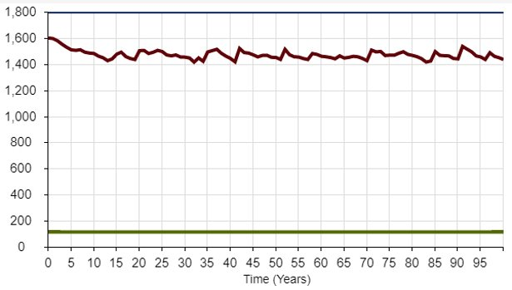

**Figure 1 -** Current mean of ice free days (114 days) with no standard deviation, no harvest, and an upper end estimate of initial abundance.

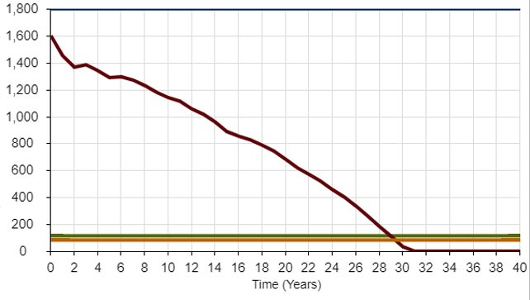

**Figure 2 -** Current mean of ice free days (114 days) with upper end estimates for population size (1600 bears) and harvest by natives (82 bears)

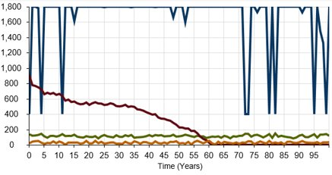

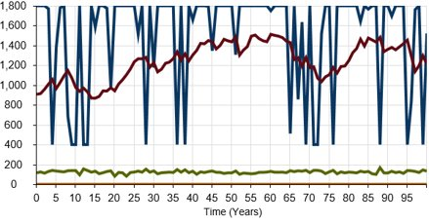

**Figures 3 -** Initializing population (900 bears) and absolute harvest (30 with standard deviation of 10) at lower end estimates, and keeping mean ice free days at 114.

**Figure 4 -** Initializing population (900 bears) at lower end estimate and no harvest, but 10 more mean ice free days (124 days)

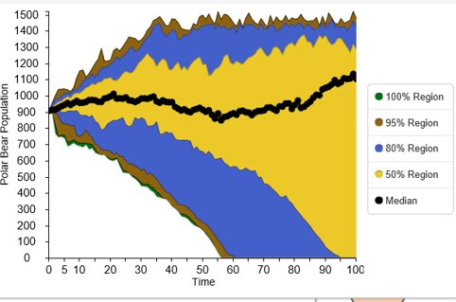

**Figure 5 -** Sensitivity Analysis using lower end estimate for abundance (900 bears), harvest (30 bears) and mean ice free days (114 days).

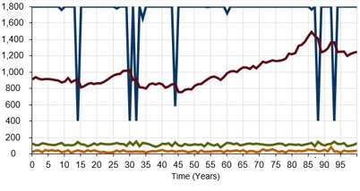 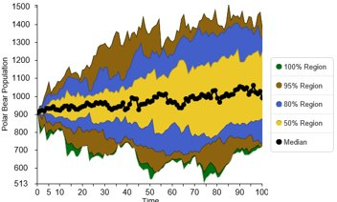

**Figure 6 and 7 -** Proportional harvest at 3% with a 1% standard deviation

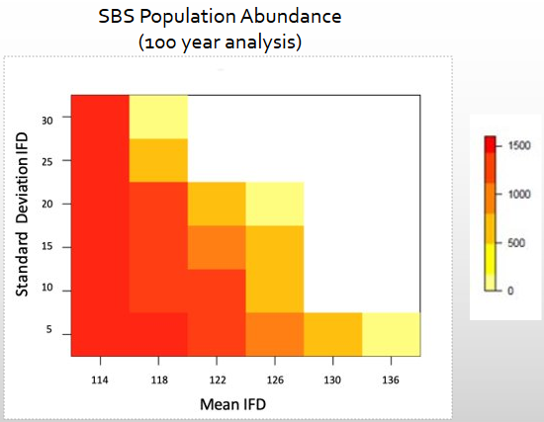

**Figure 8 -** Using data obtained from Insightmaker this heat map depicts polar bear abundance at a varying number of mean ice free days against a varying standard deviation of ice free days.

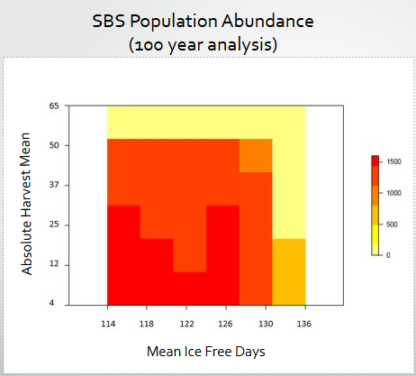

**Figure 9 -** Using data obtained from Insightmaker this heat map depicts polar bear population abundance at a varying number of mean ice free days against a varying number of absolute harvest.

High quality data on polar bear vital rates is difficult to obtain (Bromaghin et al., 2015). The habitat that polars bears thrive in is extremely inhospitable for people and the populations consist of solitary individuals with diverse behavioral characteristics. In all possible variations simulated we determined that this population is highly sensitive to heavy harvest. Polar bears provide several years of maternal care and only rear 1-3 cubs at a time, so populations are slow to recover from catastrophic events (Bromaghin et al., 2015). If climate trends continue, mean ice free days will increase over time, which was not incorporated into the polar bear PVA model so it can be inferred that the real-life scenario is potentially worse than what the model describes.

While factors such as toxins and climate change adversely affect polar bear populations, these aren’t variables that can be practically considered from a management standpoint. The only variable that may contribute to polar bear survival and that management practices can affect is harvest. Examining the heat map from figure 8 it’s evident that at the lowest number of mean ice free days (114 days), and the highest standard deviation of ice free days (30 days), the population is still viable and fairly robust. In contrast, figure 9 shows that the lowest number of mean ice free days (114 days), and the largest absolute harvest estimate (65 bears) leads to complete decimation of the population. This further supports directing conservation practices towards management of harvest, and not climate change, at this point in time.

Estimates for maximum harvest of SB polar bears are above sustainable numbers for this model, it is hypothesized that due to overlapping ranges, some bears harvested in SB sea territory may more accurately be described as belonging to adjacent clades.  It is difficult to determine exact harvest quotas for the SB polar bear population from available data, but estimates range from 20-80 individuals annually (Bromaghin et al., 2015). Since the sex of harvested bears will play a large role in how this population reacts to harvest, the next step in developing a management plan would be to gather more data on population demographics so a more sophisticated model could be designed to determine if a zero harvest or a male only harvest management strategy would most benefit the population. This would be especially pertinent during years when the number of ice-free days exceeds the 127 day threshold.  Serious hurdles are associated with any management strategy that requires putting regulations on polar bear harvest. Even though polar bears are federally protected in the united states, those laws don’t apply to native peoples who still live traditional lifestyles. These indigenous people have harvested polar bears for thousands of years and it’s a practice that is important to their culture. Natives may sustain themselves from hunted polar bears and use different parts of polar bears to produce and sell crafts.

In the absence of harvest this population will remain viable at a lower equilibrium, that being the estimated carrying capacity of the SBS region for polar bears during excessive ice-free days, 400 individuals (Bromaghin et al., 2015). A population this small faces the threat of extinction due to environmental and demographic stochasticity.

While the SBS subpopulation of polar bears is in decline and faces serious threats of extinction, subpopulations in adjacent regions are considered relatively robust. It is plausible that even though mortality in the SBS region may exceed recruitment rates for extended periods of time, the area may serve as a sink in which bears from adjacent regions immigrate into. During years in which the number of ice-free days happens to be above the 127 threshold, this rescue effect could be what saves the SBS polar bear subpopulation from extinction.

**Literature Cited**

Hunter, C. M., Caswell, H., Runge, M. C., Regegr, E. V., Amstryp, S. C. & Stirling, I. 2007. Polar Bears in the Southern Beaufort Sea II: Demography and Population Growth in Relation to Sea Ice Conditions.  U.S. Department of the Interior. U.S. Geological Survey. 1-46.

Bromaghin, J. F., Mcdonald, T. L., Stirling, I., Derocher, A.E., Richardson, E. S., Regehr, E. V., Douglas, D.C., Durner, G. M., Atwood, T. & Amstrup, S.C. 2015. Polar bear population dynamics in the southern Beaufort Sea during a period of sea ice decline.  Ecological Applications. 25: 634-651.

Allen, W. M. & Angliss. R. P. 2010. POLAR BEAR (Ursus maritimus): Southern Beaufort Sea Stock. STOCK DEFINITION AND GEOGRAPHIC RANGE Polar bears are circumpolar in their distribution. Semantic Scholar.

Martin, Amy & Mott, Nick. 2018. Ice is us: Alaska Native face the demise of the arctic ice pack. Public Radio International.